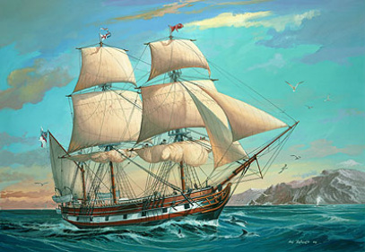
Adventures with Darwin Log Sheet
It is the year 1831 and you have just been invited to join a young naturalist by the name of Charles Darwin on an adventure around the world!
You have just boarded the Beagle and your most valuable possession is your journal. This is how you will document your observations, ideas and memories.
A map has been provided so that you can plot your journey and document the location of each destination that Darwin visited. Be sure to keep your map in your journal.
As you reach each destination, Charles Darwin will introduce you to each of the key components that support his theory of Natural Selection. He believes that natural selection is the process by which organisms that are better suited to their environment survive and reproduce more successfully than less well adapted organism do.
You are to use your journal to reflect on what you observe, answer specific questions, and share your own questions and theories. This is the year 1831, so make your journal as authentic as you would like.
Use the coordinates posted at each destination to plot your travels on a map. Then, use the space provided to answer the questions as you explore each destination.
Davenport, England (50N, 4W): home port of the HMS Beagle
Answer the following questions:
1. What is evolution?
2. Why do you think organisms change over time?

Cape Verde Islands (14N, 23W): several Islands located off the northwestern coast of Africa
Darwin explains that overproduction is a key component of natural selection.
Answer the following questions;
3. What did you observe in the video?
4. What are some other factors that would prevent the eggs from developing in to fish that will later pass on their genes to the next generation?
5. If this fish species did not produce large amounts of eggs, what could possibly happen to their species?
6. Illustrate how this video clip represents overproduction.
7. How will overproduction lead to natural selection?

Salvador (23S, 43W): port city on the east coast of South America, in present-day Brazil
Darwin explains that struggle to survive is a key component of natural selection.
Answer the following questions:
8. What did you observe in the simulation?
9. How many different types of stick bugs were present in the beginning of the simulation?

10. How many different types of stick bugs were present at the end of the simulation?

11. Which stickbug was better adapted to their environment?
12. What strategy enabled this stickbug to survive and therefore pass on its traits to the next generation?
13. Illustrate how this simulation represents struggling to survive.

14. How will struggling to survive lead to natural selection?

Galapagos Islands (0S, 90W): 22 islands located off the west coast of South America, near present-day Ecuador.
Darwin explains that inherited variation is a key component of natural selection.
Answer the following questions:
15. What types of variation did you see among the finches of the Galapagos Islands?
16. Why is variation important for species survival?
17. Illustrate how the finches of the Galapagos Islands demonstrated inherited variation.
18. How will inherited variation lead to natural selection?
Australia (33S, 151E): island continent located across the Pacific Ocean, bordering the Indian Ocean on its western coast.
Darwin explains that an organism's successful reproduction is a key component of natural selection.
Answer the following questions:
19. How did the crickets struggle to reproduce?
20. What are some other ways that organisms successfully reproduce?
21. Illustrate how the cartoon represents successful reproduction.

22. How will successful reproduction lead to natural selection?

Falmouth, England (50N, 5W) : returning port of the HMS Beagle
Answer the following:
23. What four key components did Darwin use to explain natural selection?
24. How does natural selection explain evolution?

